- Forms – SMS MFA required to reopen an Application

- NOTE CUSTOMER FACING
To protect partially completed application form data being accessed by malicious users using digital tools to generate Application IDs, a new feature to protect Application Form data is being installed.
When an applicant has provided their Email and mobile number by either:
A - Selected SAVE application form, or
B – Passing to the next module after the customer module (and provided personal info including email and mobile phone number)
And the customer either copies the URL to another browser, or resumes their application from the link in the SAVE email, then the customer is presented with the same screen as the Customer Portal access and is asked to request their one-time code via SMS.
The applicant will regain access and resume their application once the 1 time password has successfully been provided.

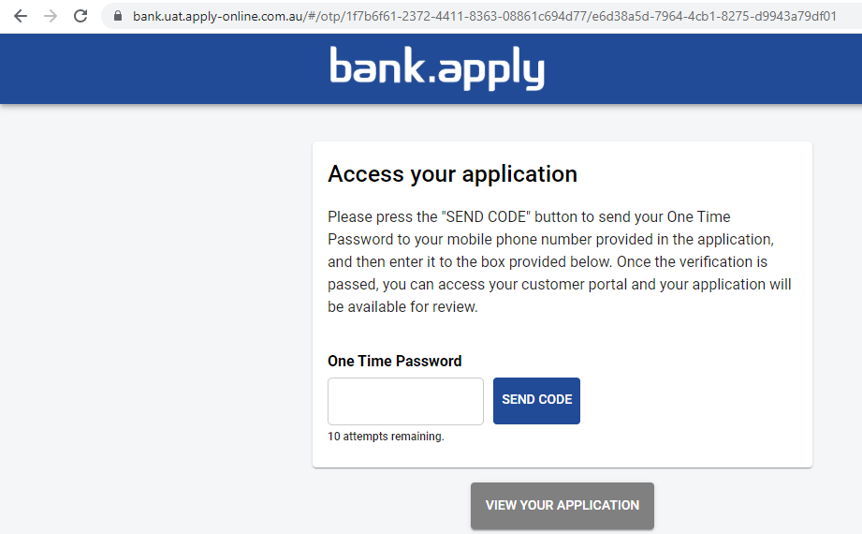

- Forms – Purpose: limit products within single form

In Form Builder, The purpose Home and Personal Loan values are set by selecting EDIT against the Loan Value, selecting OPTION and entering the high and low limits.
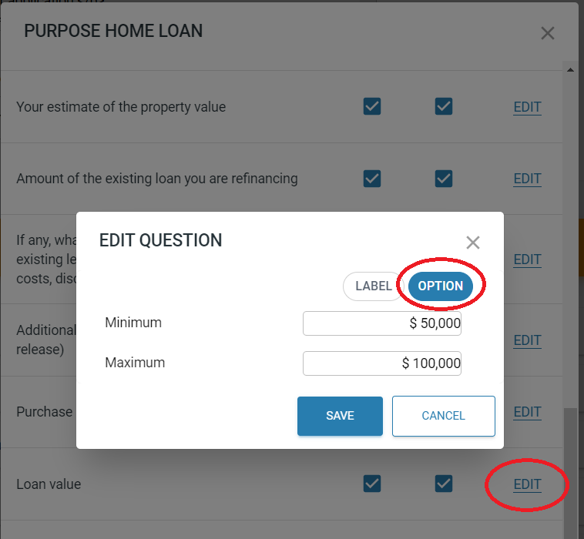
Where the requested amount is lower than the Minimum value the loan amount will display:

Where the requested amount is larger than the Maximum value the loan amount will display:
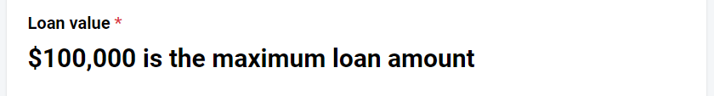
- Forms – Product selection: link products available to individual application form

To specify products for an individual application form select the product Purpose module and under Products EDIT, select OPTION, and select the products that will be displayed in the product selection module.

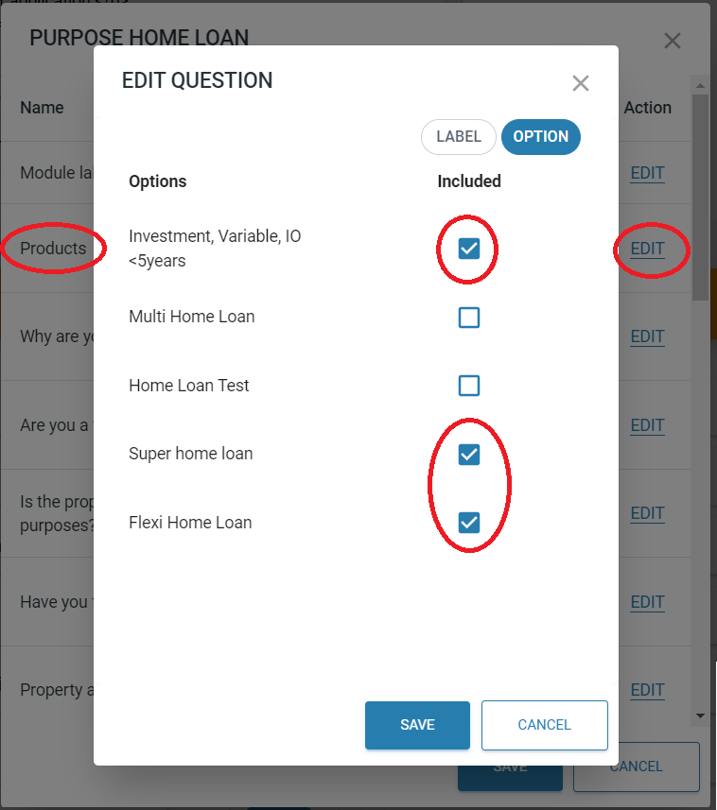

- Forms – Product Selection: Limit loan term and payment frequency to selected product management parameters

The maximum loan term for the product selected (as Determined in Management - Product settings) is displayed as the maximum loan ter. In this example 20 years is the maximum term.

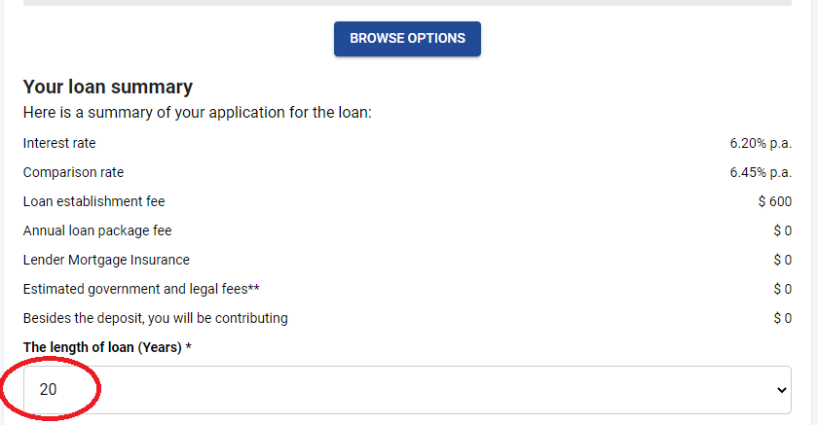

- Forms – Income: Move Bank Statement provided ‘centrelink’ payments to Income other

Centerlink payments when retrieved from Bank Statements have been moved from Income Employment to Income other to align to existing Nimo ruleset functionality
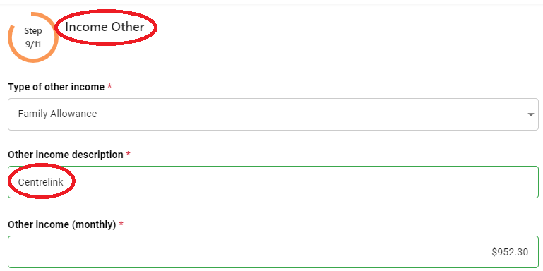
- Forms – Income: Select number of payslips provided at application level

The number of payslips required when completing an application form can be selected.
Also remember to update the Label text to match the number of payslips required.

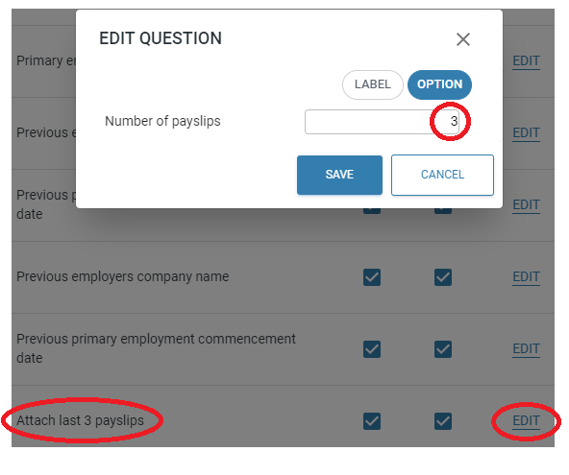

- Assessment – Pipeline builder uplift (view full ruleset when editing all pipelines)

When reviewing your individual Application pipeline (Assessment rule builder), you will have access to the full ruleset including all the latest rules. All new rules are turned off by default.

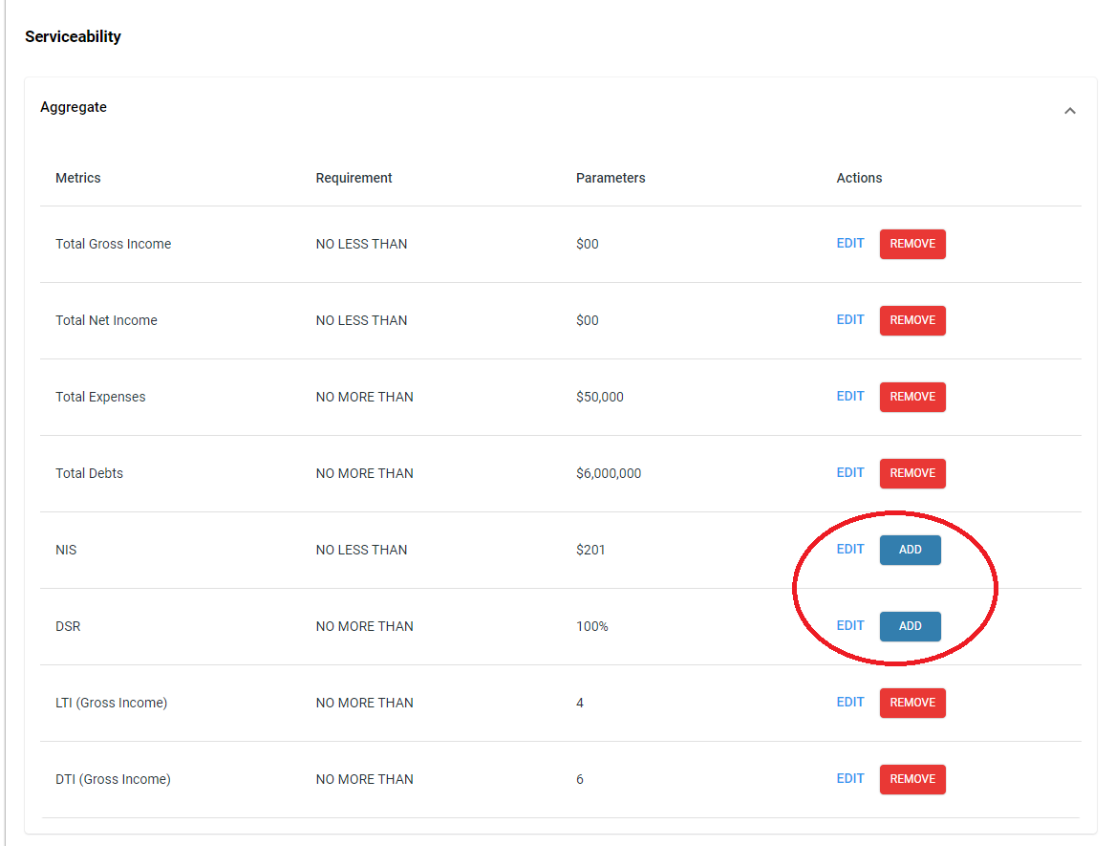

- Assessment – Credit Bureau Fail/Restore (see reason why check failed and rerun report)

A feature to determine the reason for unsuccessful Credit Bureau Check, resolve and recheck has been provided to assist with this regular technical exception
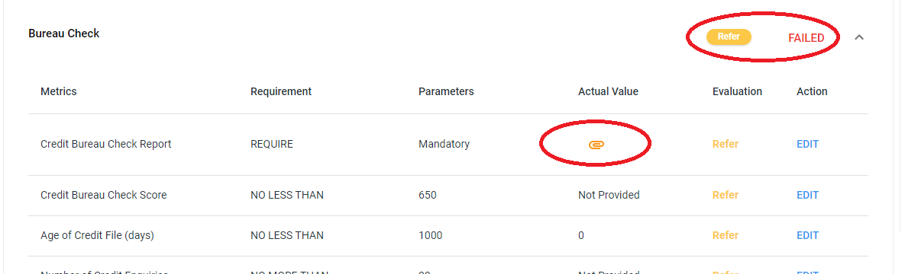

Click the Paperclip to show the item(s) while the Credit Check failed.
Resolve items.
Clicked FAILED text to request a new Credit Check by selecting the REQUEST button below.

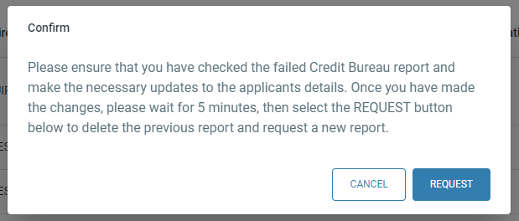

- Assessment – add manual property valuation regardless of service.

Select EVALUATE in Assessment - Assets - Property

Select Certified Valuation
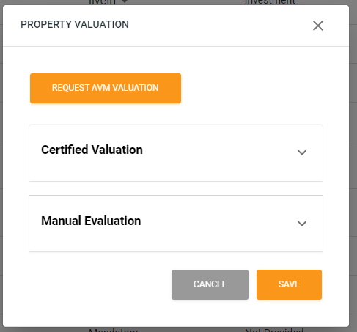

Enter Certified Valuation and SAVE (add Valuation PDF to Conditions – Assessment Attachments)
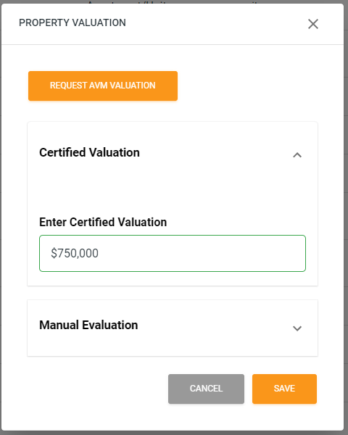

- Settlement – reinstate page regardless of service (standardise the SETTLED function button across lenders)
In preparation for the update in the Lextech integration and the addition of Gadens, a standardised Settlement screen is being installed where ‘Settlement – Solicitor’ is selected in the product setup.
Note: This does not affect products setup with NimoSign as it will continue as normal.

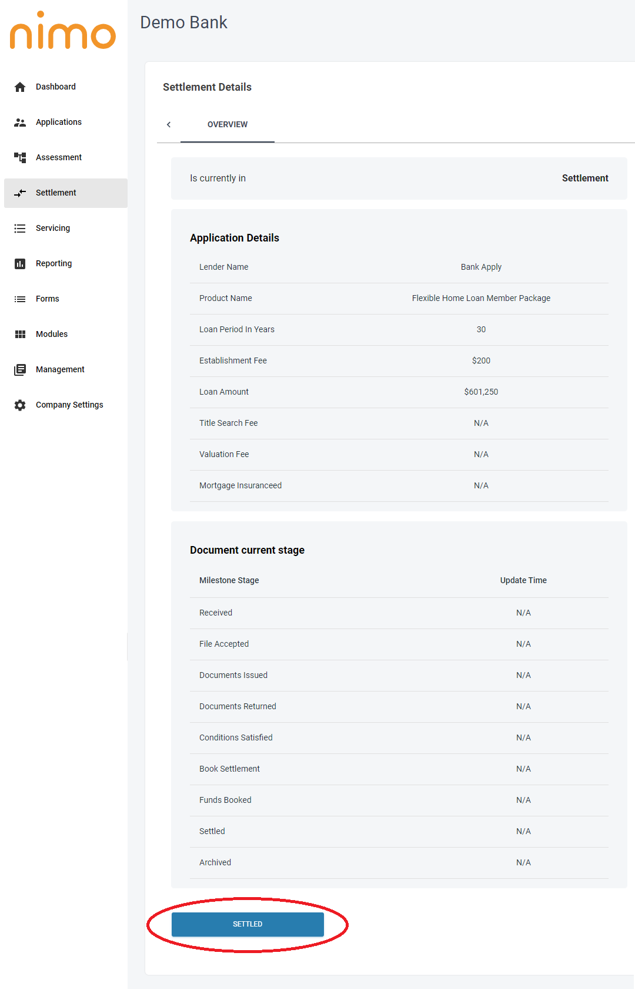
- Estimated Stamp duty estimate where the property is not found added

The Stamp duty calculator is being updated with an added value of State where an applicant has not found a property to more accurately calculate the estimated stamp duty by providing the new value of State or territory of the applicant is looking for the property.
