Summary Page

- Cash Flow Figure: We have added a cash flow figure to the application overview page, which indicates whether the customer's cash flow can service the loan excluding the credit policy rules being applied. E.g., If the cash flow is negative without the credit policy rules applied, the application should not be submitted for assessment.

- Available Funds or Shortfall: The funds position available funds or shortfall has been added to the overview page to indicate whether the customer has enough funds to complete the purchase or refinance.

If there is a shortfall indicated, the lender can block the application from being submitted to the assessment team. To achieve this, we have added an option in the “Company Setting” layer where you can choose to ignore the shortfall and allow submission for assessment or block submission to assessment if there is a shortfall indicated.

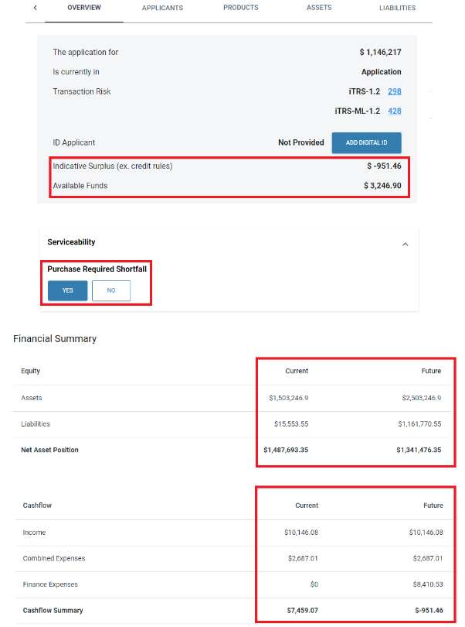

Personal Loan summary page - Funds required and loan type.

Summary page and overview page now displays the correct funds position to show available funds or shortfall.

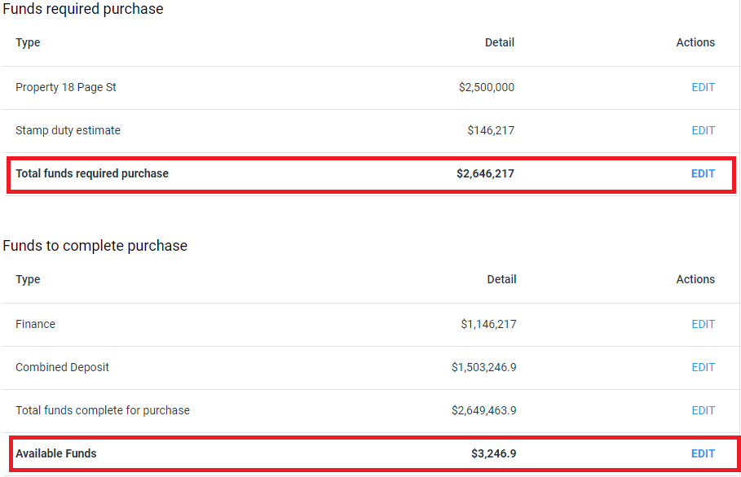

Personal Loan Purpose – NIMO-252

The application product and summary tabs both now displays the purposes selected by the customers from the online application form.

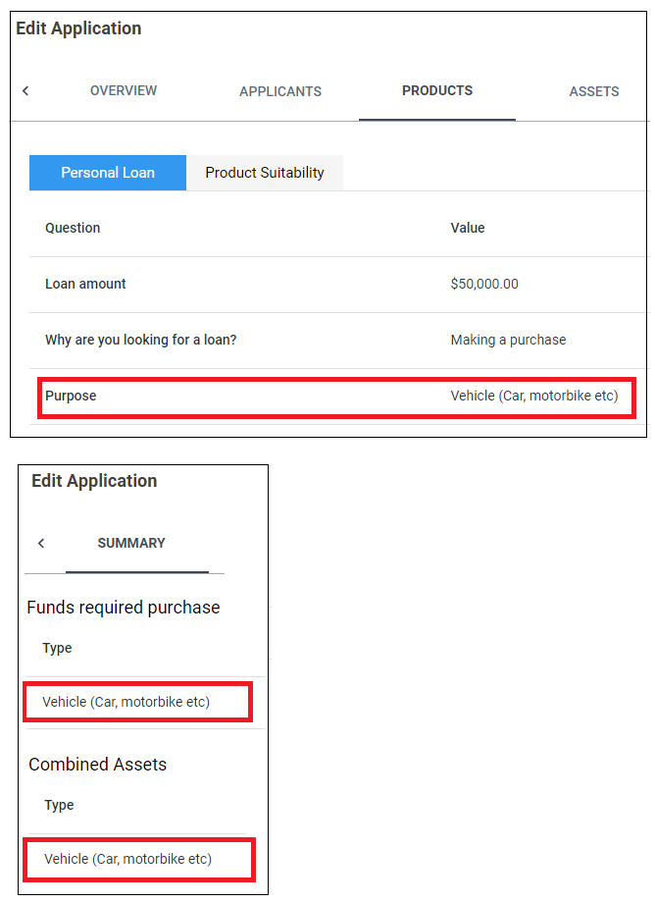

Home Loan & Personal Lender assessment pipeline

The serviceability assessment pipelines for Home Loans and Personal Loans have been separated to enable the use of independent credit rulesets.

Please ensure that you review and update the assessment pipeline ruleset for each loan type separately e.g., adding or removing the necessary rulesets and updating buffers (if applicable)

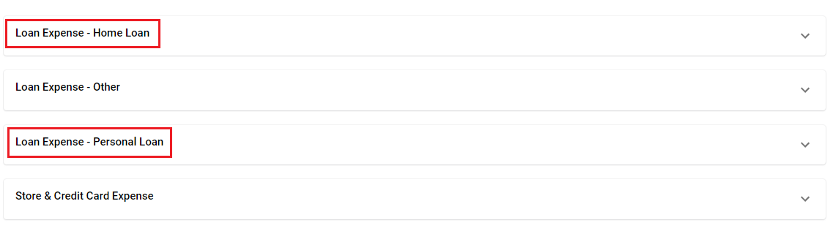

Assets and Liabilities – Allows customers to select if a loan is being refinanced which will zero out the value to avoid double ups.

Liabilities

When an existing loan is being refinanced, at times the bank statement retrieve process will display the same loan within the liabilities tab under the application layer causing a double up of liabilities.

To avoid this, we have added a question within the customer application form and staff application/liability tab to select “Yes” or “No” to zero out the value.



This option is also included within all existing liabilities, which allows the customer to use if they are consolidating debit within the new loan.

Assets

All existing retrieved bank statement deposit account values are included in summary under “Combined Deposit” for the current position and future position will display the Combined Deposit minus the deposit paid for purchases (if appliable)

