Tax File number Field including delete option and Report

When the customer enters their tax file number in the field provided in the customer application form, it will appear in the applicant tab of the application layer within the NIMO's staff portal. This will provide you with an option to delete the contents of the tax file number field after the value has been noted.

In the Reporting Layer, a report has been created called "Applications with Tax File Number (TFN)".

This report scans deals from the last 90 days and displays the number of files still showing a value in the tax file number field.

By clicking on 'view', it will provide a list of the customer application links to enter and delete the Tax File Number value.

Step 1 – Make TFN question active in the customer details module.

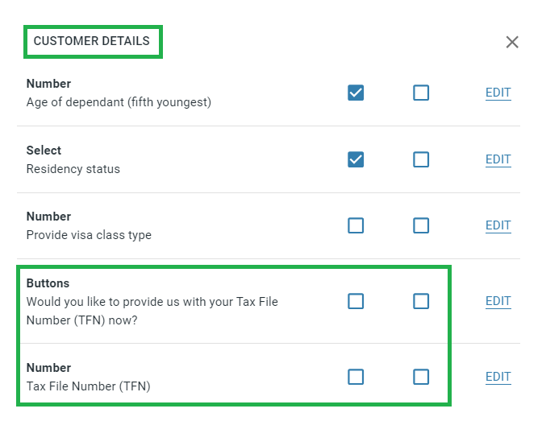

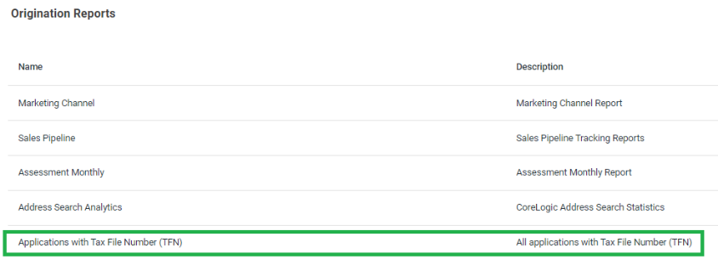

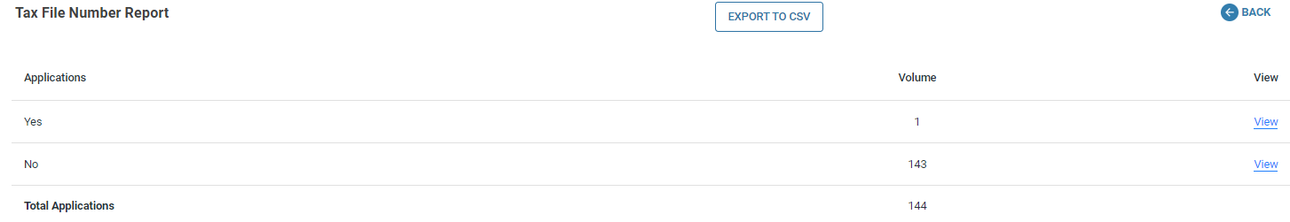

Sales Pipeline Timeframe.

A new report provides the average timeframe in days between different stages of all applications over the last 90 days. The reporting will commence from the production deployment date moving forward.

The report provides a view each category type.

- Home Loan
- Personal Loan
- Vehicle Loan
- Business Lending
- Personal Deposit

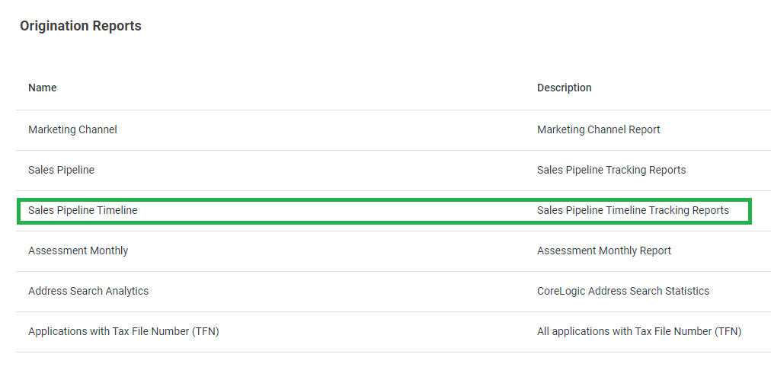

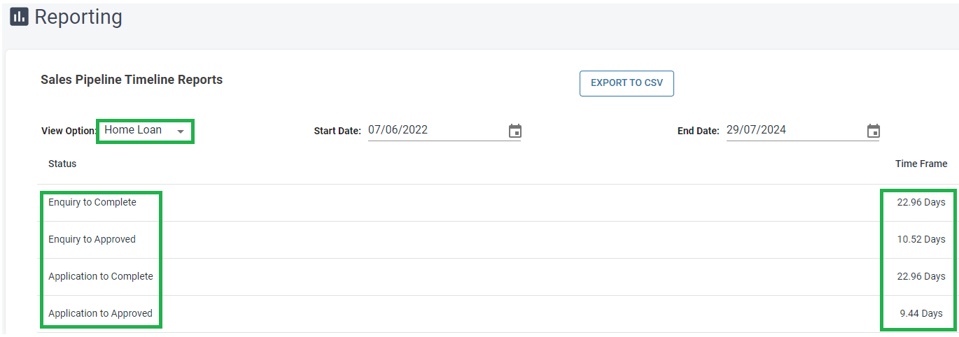

Withdrawal Button option
The withdrawal button is used when applicants decide not to proceed with the deal. This option is available at all stages of the application process.

When pressed, the application status is changed to 'withdrawn' and moved to the withdrawal tab section of the main application dashboard.

The withdrawal status will be sent as a 'deleted' in the interim while we provide you with the specifications to update your CRM over the next four weeks.

Note: The application can be restored if necessary.

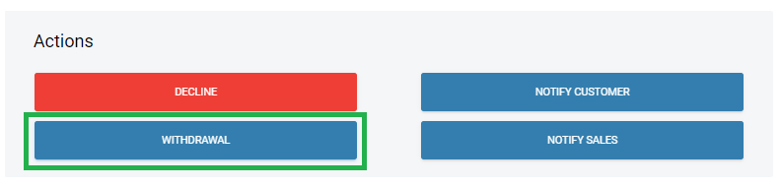

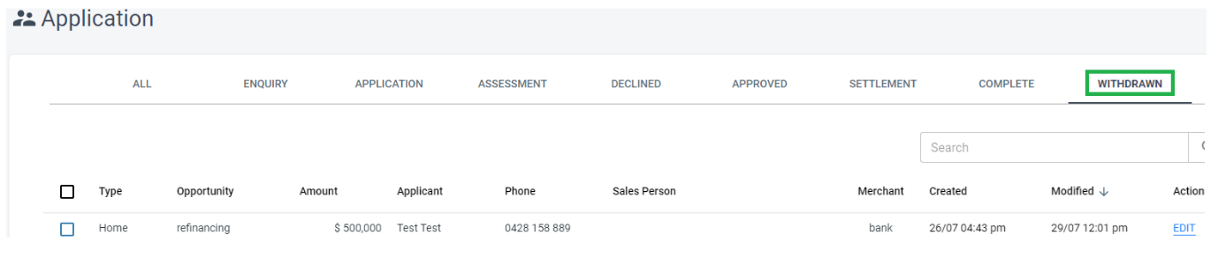

Include Loan fees

Located under Marketing > General settings.
When ‘Yes’ is selected establishment and other fees will be capped into the loan and displayed on the financial position module/page and liabilities tab in the staff portal.

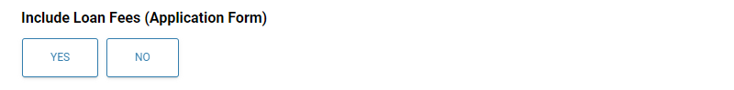

Solicitors & NimoSign Communications added.

Previously, the approval communication was sent, which included the link to sign personal loan contracts.

We have now created two new communications specifically for:

- Solicitors notification: This sends a communication to the customer once the "Submit to Documents" button is pressed under the assessment layer > contract tab, informing the customer that loan contracts have been requested for this home loan.

- NimoSign notification: This sends a communication to the customer once the "Submit to Documents" button is pressed under the assessment layer > contract tab, including a link to the customer portal for signing their personal loan contracts.

Note: Recommendation is to review the ‘Application Approved’ communication.

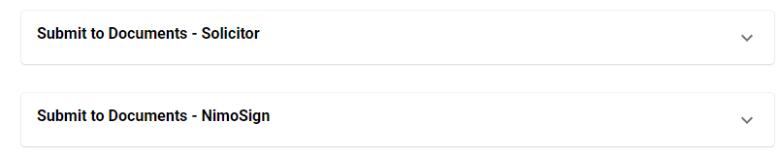

Allianz Insurance Quote – Property & Vehicle integration.

The Insurance Quote module (form builder) will use the values inputted by the customer to pre-populate the Allianz insurance portal, providing a quote for Home and Landlord insurance.

