Multiple Lot numbers - Land titles (Assessment layer)
When requesting a land title and encountering distinct Lot numbers in the address, a dropdown menu is presented, offering a selection of all available Lots to choose from

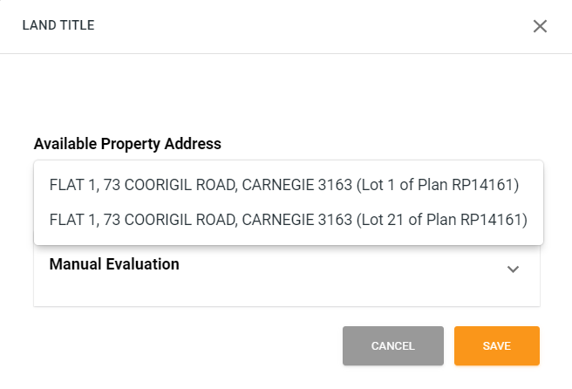

Credit Summary (Assessment layer)
The credit summary screen offers a concise overview of key credit assessment metrics essential for evaluating a loan application. (The data is gathered from various layers within the Nimo application and assessment layers)
Please note:
In case of multiple applicants, this information will be presented within the customer section.
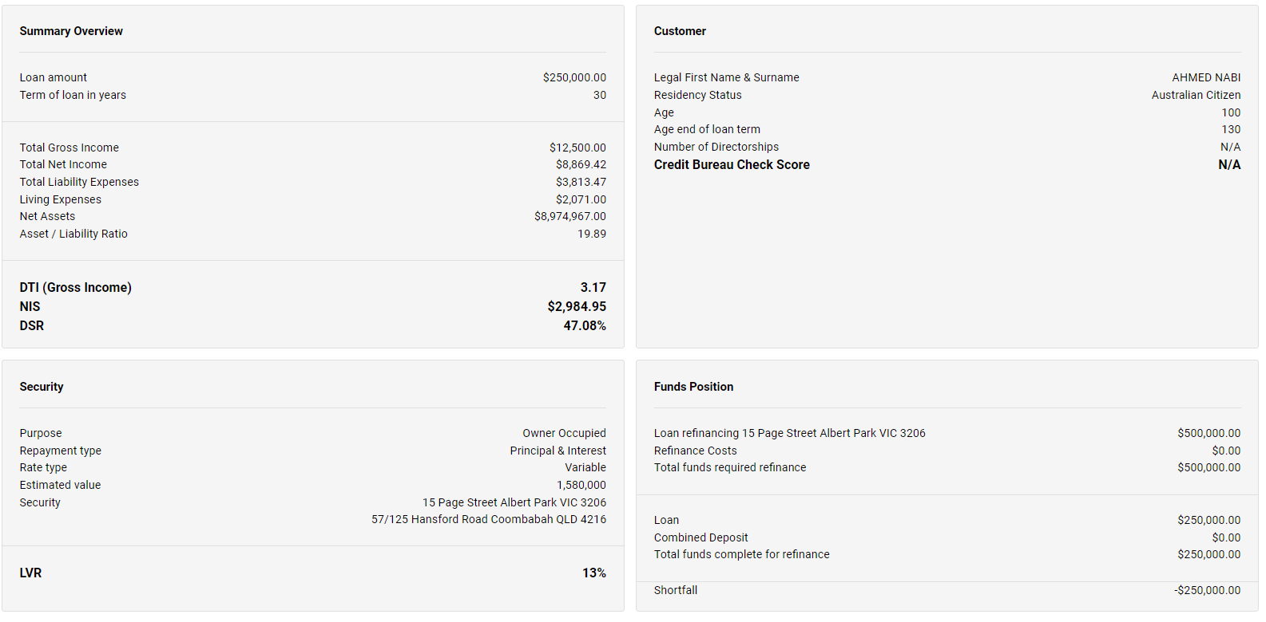

Loan Payout Figure & Payout (Servicing layer)
In the 'servicing' portal for merchants, within the 'loan repayments' tab, merchants will find the option to settle and close their existing loan facility.
Note: If there is a pending direct debit in progress, the closure will not be processed.
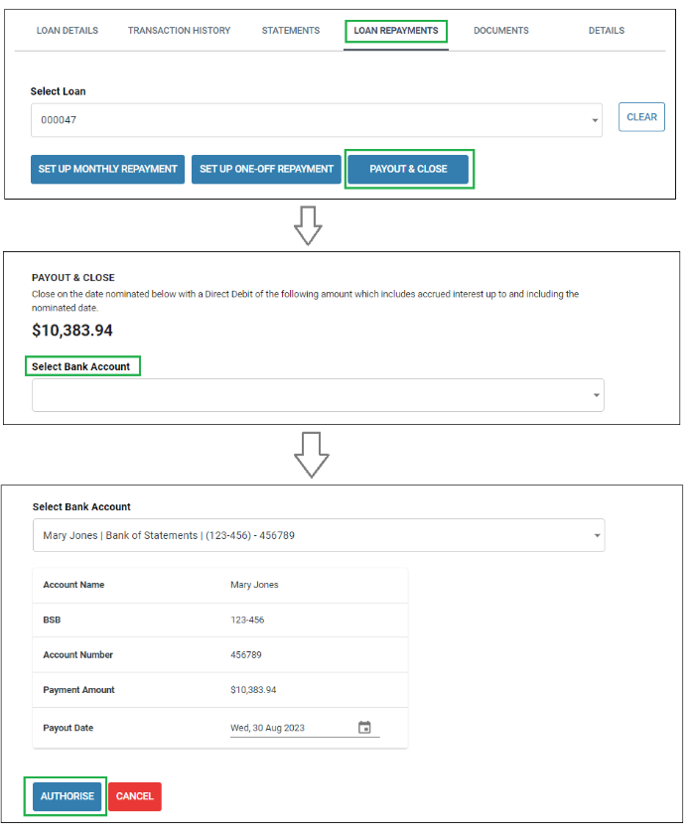
Payout and Close communication added to the communication tab in company settings.
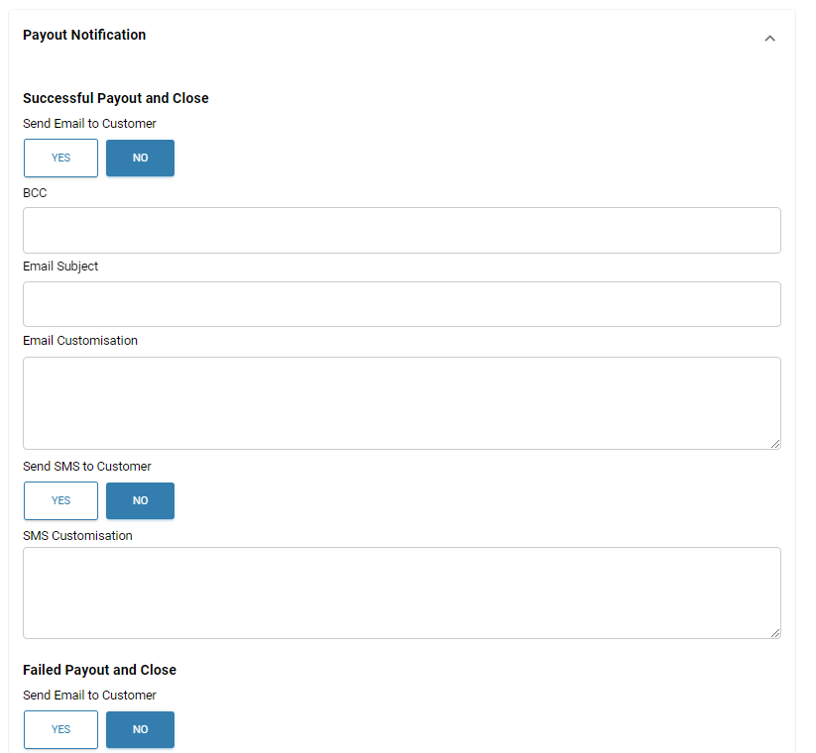

HubSpot Update
Enhanced functionality now allows you to choose specific fields for synchronisation with Hubpot. You can do this by selecting your preferences in Company Settings > Integrations > Hubpot.
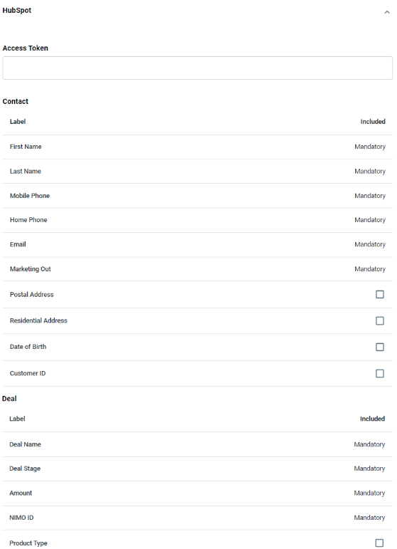

Date Picker and Validation (customer user form)
All date sections are now equipped with a date picker and a date range feature to prevent customers from inputting unrealistic dates.
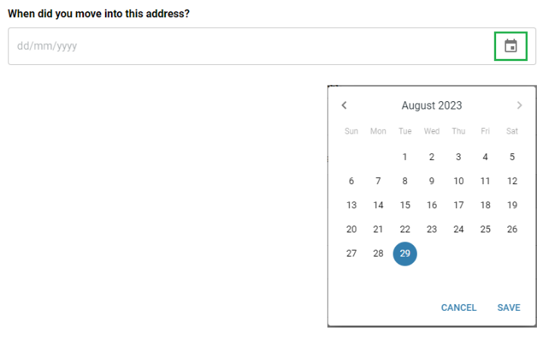

Google Tag Manager now available – please reach out to support to assist in support.

Add new manual Direct Debit & Disbursement Account (Merchant Servicing layer)
Merchants now have the capability to add a new account manual for direct debit that are not verified through the Illion bank statement process. You can access this option in the dropdown menu under 'Select Bank Account'.
This option is available is also available in settlement layer for loan disbursements.

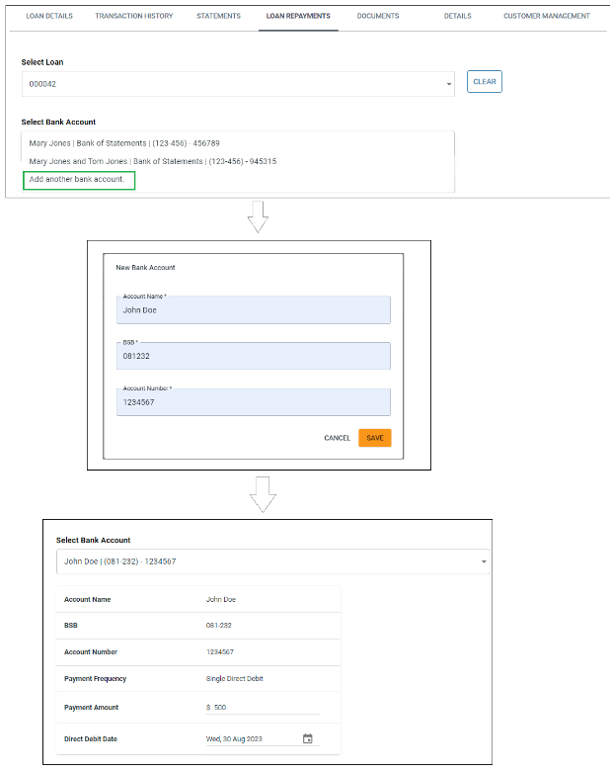
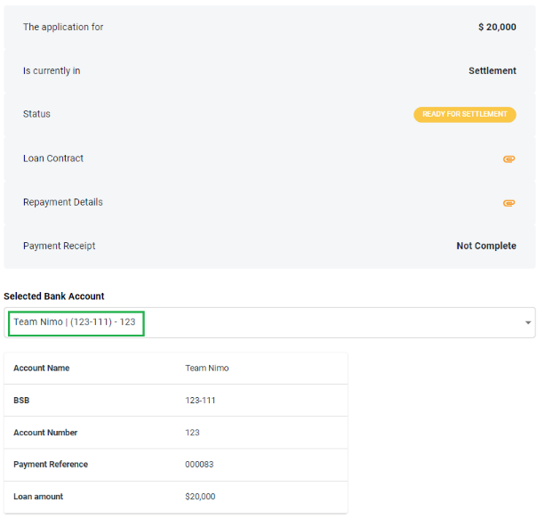

Notes Enhanced (application & assessment layer)
The notes section has been enhanced to include the option to add Category and Subject. These details can be added in either the application or assessment layers and will be visible in both layers.
Note Categories

- General
- Interaction
- Credit
- Warning
- Fraud
- Dispute
- Transaction
- Important
- Notify Staff
- Notify Customer
- Other

Note: When you press the 'Notify Customer/Sales' button, it also automatically generates a corresponding note.
