Background image
Merchants now have the capability to incorporate a background image into user application forms. You can find this feature within the company settings layer under the 'General Settings' tab in the 'Media' section.
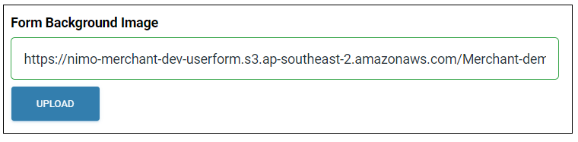
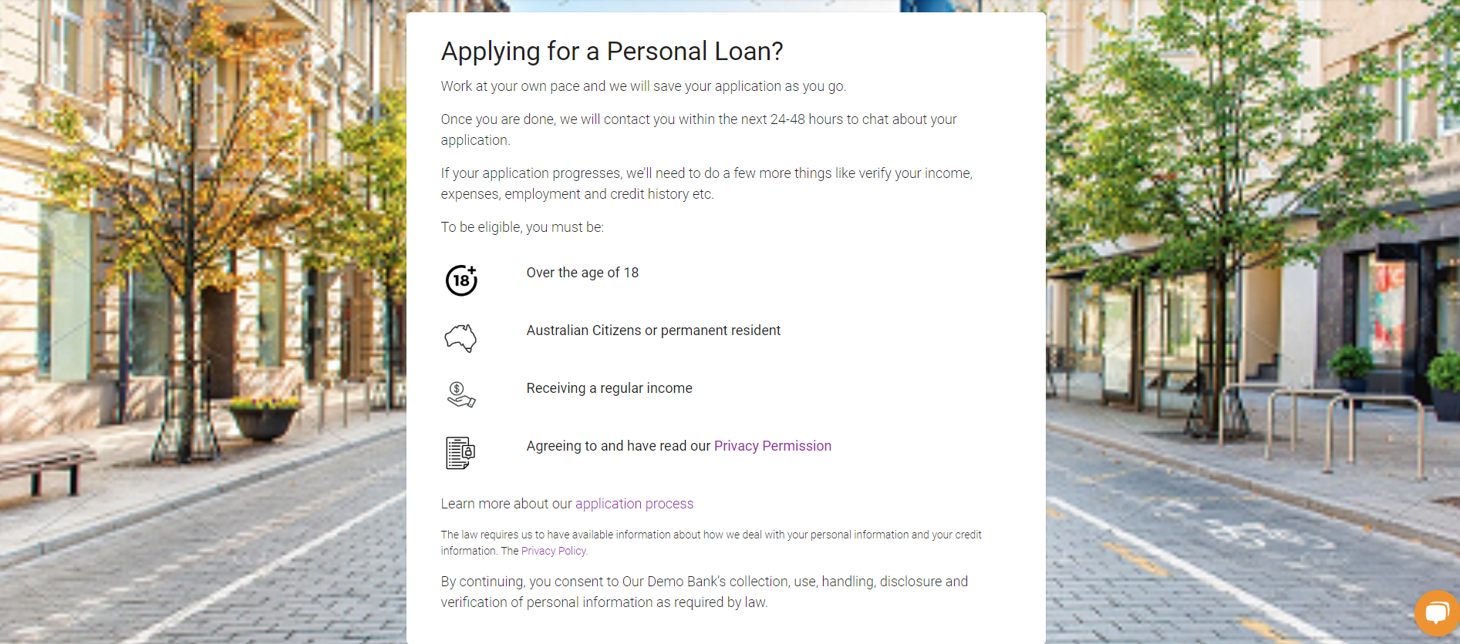

Option for Upcoming Direct Debit Reminder Notification
Access this feature by navigating to the 'Company Settings' tab, then select 'Communications,' and finally, you'll find the 'Upcoming Direct Debit Notification' option.
This communication setting enables you to specify the number of days before the scheduled direct debit date when the notification should be sent.

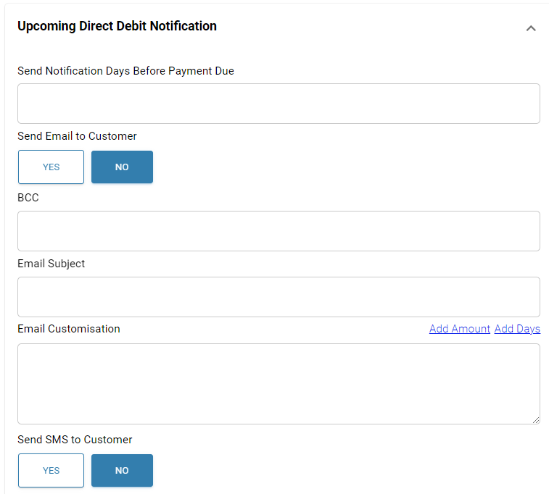

Automatically decline applications based on the ITRS or ITRS-ML score.
When opting to utilise iTRS and/or ITRS-ML, a field will be presented where you can choose to automatically decline an application if its score falls below a specified threshold.
Please note that if this option is enabled, it will apply to all applications, irrespective of their product type.
The logic behind this is that if both iTRS and ITRS-ML auto-decline features are activated, both conditions must be met for the application to be automatically declined.

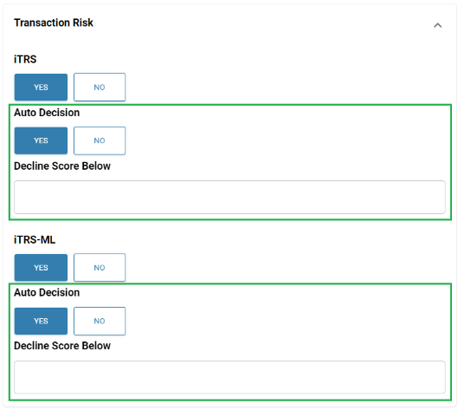

Include Internal Supporting Documents
Now, you have the capability to include internal supporting documents in the 'Documents' tab, which will be accessible exclusively to staff members. These documents may include items like assessment notes, approval emails, and more.

