- Multi-Loan module - splitting loans, cross-securing, multiple products
The Multi-Loan module, empowers staff, brokers, and customers to tailor their loan structures.
Key Features:
- Streamlined application process for purchase, refinance, or a combination of both within a single application.
- Split Loans: Customise each loan with its unique needs analysis and product selection.
- Cross-Securing Loans: Enhance flexibility and loan structuring options.
It's important to be aware that the LVR value on the credit summary page is currently under review, and as a result, lenders need to conduct a manual assessment of the LVR in the meantime.
For more details and to schedule a training session, please don't hesitate to reach out.
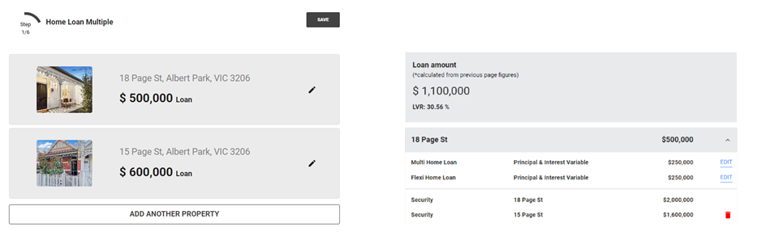
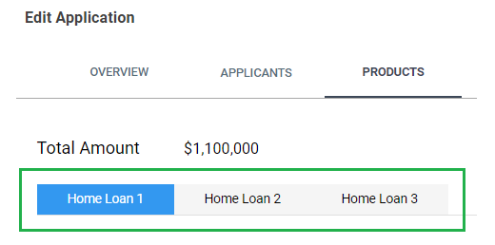

- Lextech integration upgrade for Purcell Partners (XML loader to API).
If you have chosen Purcell Partners as your solicitor for mortgage documentation, please get in touch with us to initiate the setup process.
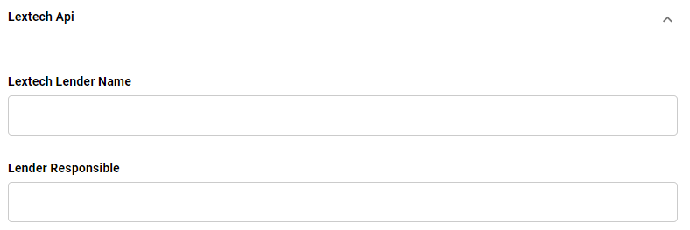
After loan approval, please navigate to the “Contracts” tab below and click the “Submit to Documents” button.
If you are using Ultracs customer/account numbers, a pop-up window will appear, enabling you to enter the corresponding customer/account number details. Please note that these details must be unique.
If you are not using Ultracs or using Nimo allocated Numbers, the pop-up window will not appear; instead, please proceed to the next step.
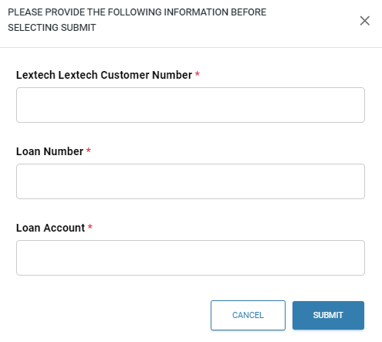
Then, proceed to the “Overview” tab and click “Submit to Settlement.”
This action will transmit the information to Lextech for Purcell Partners.
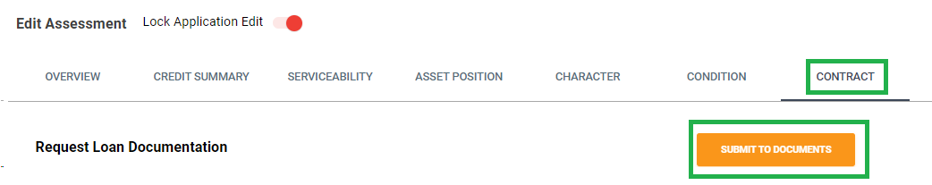
When Lextech successfully receives the information from NIMO, it will provide a Lextech timestamp as the file progresses through the setup stages, visible in the settlement layer document stage view.
The following examples indicate that Lextech has advanced the stage to 'Funds Booked”.
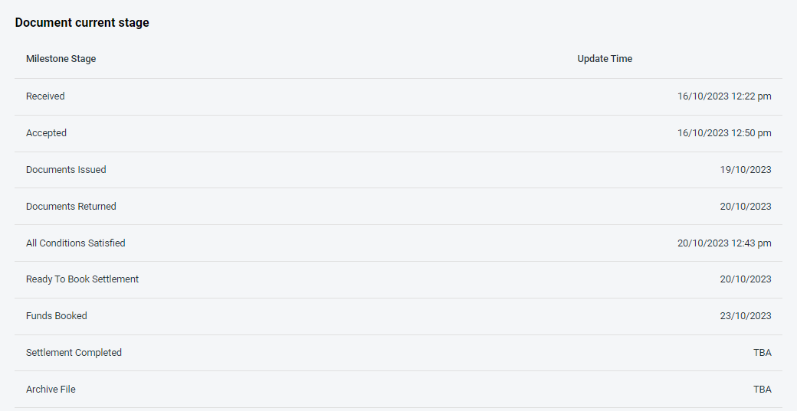

- Updated Notes: DLA Approval field added to allow categorisation of approval levels.
New Notes Categories added:

- Important
- Fraud
- Collections
- Hardship
- Write Off

DLA Approval Categories:

- Staff
- Credit Assessor
- Credit Manager
- Head of Department
- Manager
- Team Lead
- Regional Manager
- Executive
- Board
- Auditor
- Regulator

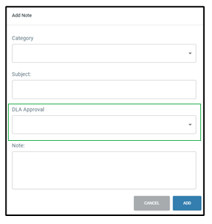
- Living Expenses Change Log
A change log has been incorporated into the application layer to track adjustments related to living expenses.
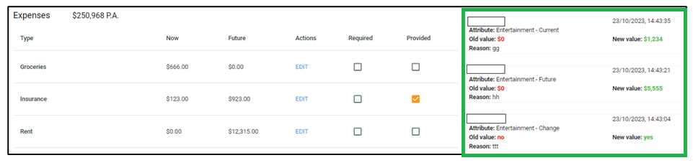

- Interest-only loan Calculation

When selecting an interest-only loan option, the repayments for assessment will be based on the remaining term, rather than the full term.

For example:

Total P&I term: 30 years
First 5 years as interest-only
Remaining term for assessment: 25 years (P&I term)

- Deletion Functionality for Assets and Liabilities
We have introduced a 'Delete' button in the application layer to facilitate the removal of manually added assets or liabilities. It's important to note that new loan liabilities, or liabilities retrieved from bank statements cannot be deleted using this feature.

