- Personal Loan purpose categories including the option to add a security.
We have introduced a new feature that enables customers to specify the purpose for applying for a personal loan. Additionally, customers now have the option to add security.
The dropdown menu will appear when 'Making a purchase' is selected, providing a list of options. If the client chooses to add security (e.g., a vehicle) and selects 'yes,' it will expand to include a set of vehicle details questions.
You can choose which purpose options to display by navigating to:
- Navigate to the Form layer.
- Click "edit" next to the form.
- Click the "edit" button on the Purpose Personal Loan module.
- Click "edit" next to the label "What do you want to purchase with the new loan?"
- Check or uncheck the desired options.

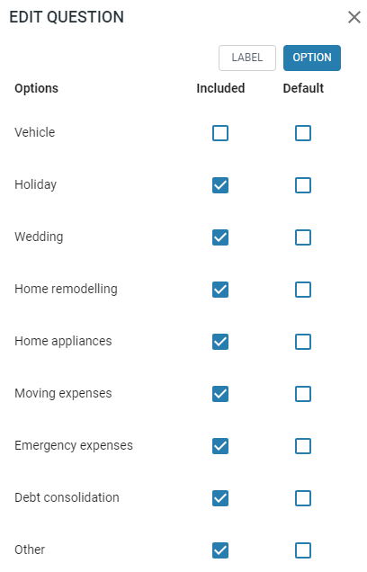
If the customer selects 'yes' for the add security question and completes the vehicle details, this information will play a role in the needs analysis to accurately display the appropriate security product on the product selection page.
If the customer selects 'no' for the add security question, this decision will also play a role in the needs analysis to display the correct unsecured product on the product selection page.
Note: No changes are required within the products. While this option allows for a purpose vehicle to be selected, it is suggested that the car loan remains a separate form due to additional questions, such as 'Have they found a car,' etc., for conditional approvals.
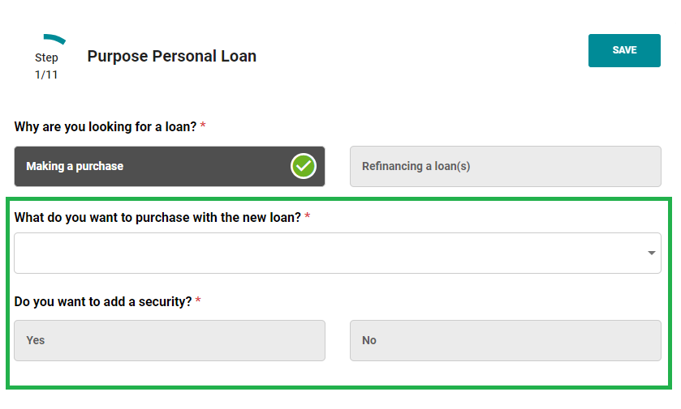

- Change logs have been added for Income, Liabilities, and Assets in the application layer.
The following example illustrates the details of multiple changes within the income section, along with the corresponding change log generated for each alteration.
Please note that when you make a change and click the save button, a pop-up will appear, allowing you to add comments for all the modifications you have made
