- Credit Summary tab now includes Product name, type and purpose for home loan and personal loans. (Assessment Layer)

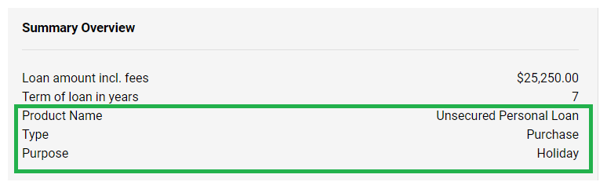

- Ability to add Decimal Points (Application Layer)
Now, you can add decimal points by clicking the edit button in the application layer's product tab.

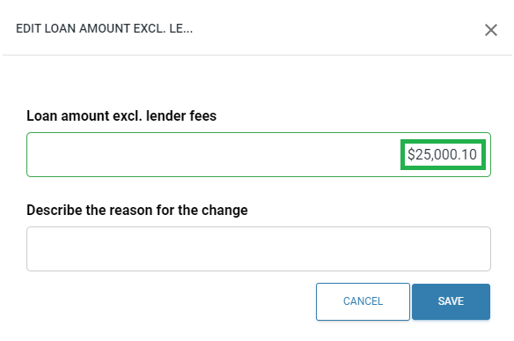

- "Other" to be non-taxable income in Other Income (Assessment Layer)
The "Other" income type in the "Income Other" section will now be calculated as net income. In the next sprint, a new "Other (gross)" type will become available.

- New Income Other Rules. (Assessment Layer)

In the Income Other section of the assessment pipeline, click "Edit." The new rules listed below will be available for selection, and you can assign a weighting to them. Ensure that you also enable these options in the form builder.

- Property Rental (net)
- DSR (Net)

- “Liability Limit” rule for “Liability Credit Card” & “Liability Store Card” (Assessment Layer)
Located in the Liability Store Card and Liability Credit Card section of the assessment pipeline

- Broker Portal (Application Layer)
While we are working on additional updates in the near future, the broker portal is ready for use by merchants.

- Equifax Credit Bureau Integration (Assessment Layer)
If you already have credentials, please enter your username and password in Company settings > Integrations and select all the Equifax Credit Bureau rules through the assessment pipeline.

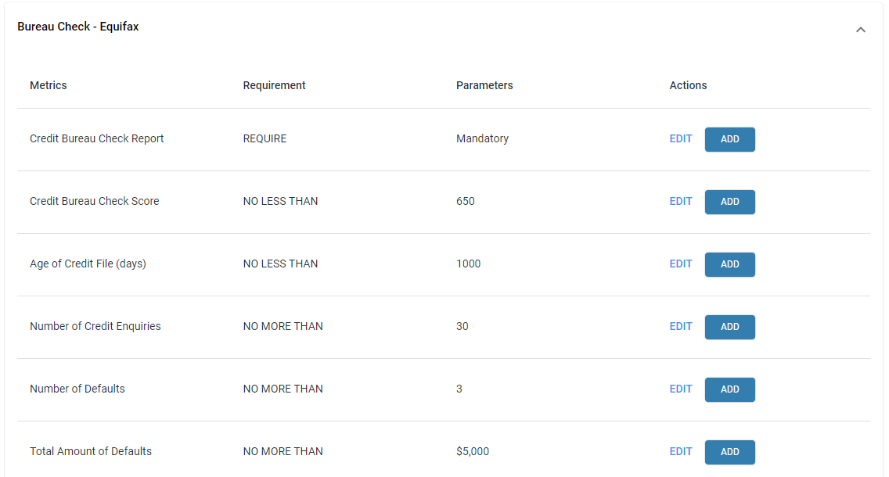

- Conditional Approval wording change in drop down. (Assessment Layer)

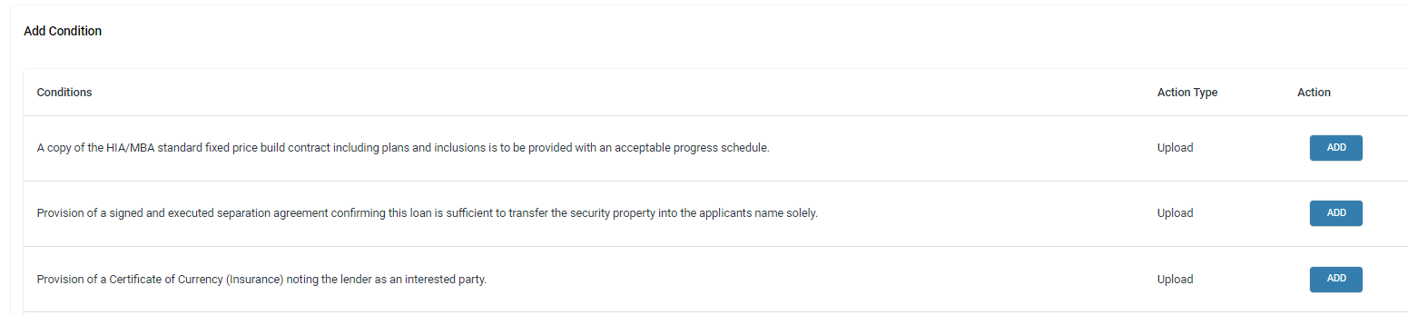

- Security updates and maintenance
- Merchant specific requirements.

